TN SKILLS PROJECT



DEPARTMENT OF COMPUTER APPLICATIONS

ALPHA ARTS AND SCIENCE COLLEGE PORUR, CHENNAI
(Reaccredited by NAAC and Affiliated to University of Madras)
COLLEGE NM ID: UNM1429

OCTOBER 2026

PROJECT TITLE:

AI-Augmented Backend Development

AI FIT TRACK API

TEAM DETAILS:

TEAM ID: 6ab4bedf6603573ccfb4e9b9 / SWTID – 2026-4469

TEAM MEMBERS:

TEAM LEADER: EZHILARASI PUNIDHAN
NM ID: 106D544A234CB989A844A86F0FDF4A97

TEAM MEMBER: MAHALAKSHMI R
NM ID: 61EDDEA27E8531AB0454DC824BCBF585

TEAM MEMBER: MOHAMMED IMRAN A
NM ID: A52FE6AD85E7114B1A44EBB617CC2402

TEAM MEMBER: SAVITHA H
NM ID: 367FAF98E5B000B811D4596387B6054F

OBJECTIVE:

The main objective of the FitTrack AI backend is to develop a secure and intelligent RESTful application that simplifies workout tracking and provides personalized fitness recommendations and insights.
The project aims to:
- Develop a RESTful API using Node.js and Express.js for authentication and workout-related operations.
- Store and manage user and workout information efficiently using MongoDB and Mongoose.
- Provide secure user authentication using JWT and protect passwords using bcrypt.js.
- Provide complete CRUD operations for creating, viewing, updating, and deleting workout records.
- Allow users to search workout history using workout name, category, or workout date.
- Integrate Google Gemini AI to generate personalized workout recommendations.
- Generate AI-assisted fitness insights from workout statistics.
- Maintain data integrity through schema validation, protected routes, and centralized error handling.
- Use a modular MVC architecture so the backend can be maintained and extended.
- Support integration with web, mobile, and third-party applications through JSON-based REST A

PLATFORM AND TECHNOLOGY USED:
The following platforms and technologies are used to develop the AI FIT TRACK API
Platform / Technology | Usage
Node.js | Runtime environment for the backend server.
Express.js | Framework used to develop RESTful APIs and handle routing.
MongoDB | Primary NoSQL database for users and workout data.
Mongoose | ODM used for schema definition, validation, and MongoDB communication.
JavaScript | Main programming language for backend development.
Google Gemini AI | Used for AI-powered workout recommendations and fitness insights.
JWT | Used for authentication and authorization of protected APIs.
bcrypt.js | Used for secure password hashing and comparison.
Postman | Used for API testing and endpoint verification.
Visual Studio Code | Used as the code editor and development environment.
npm | Used for dependency and package management.
dotenv / CORS | Used for environment configuration and cross-origin request support.

IMPLEMENTATION / PROCESS
The implementation of the FitTrack AI system is carried out through the following steps:
Project Setup – Create the project folder, open it in Visual Studio Code, create the server structure, initialize Node.js using npm, and install the required dependencies.
Backend Server Development – Node.js and Express.js are used to build the server. The Express application handles HTTP requests such as GET, POST, PUT, and DELETE.
Database Configuration – MongoDB is configured as the primary database and Mongoose is used for schemas, validation, timestamps, and communication with MongoDB.
User Authentication and Security – JWT is used for token-based authentication. Passwords are securely hashed using bcrypt.js and middleware protects private routes.
Workout Management – Workout records contain workout name, category, duration, calories burned, workout date, and user information. CRUD operations are provided.
Workout Search – Users can search their workout records using workout name, category, or workout date.
AI Integration – Google Gemini AI is connected through a dedicated service layer to generate personalized workout recommendations and fitness insights.
Recommendation Processing – User age, fitness goal, and experience level are supplied to the AI service to produce personalized guidance.

Fitness Insight Processing – Total workouts, average workout duration, and calories burned can be analyzed to produce fitness insights.
Error Handling and Validation – Centralized error handling and Mongoose validation are used to maintain data integrity and consistent API responses.
API Testing – Postman or ThunderClient can be used to test registration, login, workout CRUD, search, and AI endpoints.
Execution – The backend server is started using the project start command and endpoints are accessed through an API testing tool.

PROJECT ARCHITECTURE:
The FitTrack AI backend follows a layered architecture. The architecture separates the API interface, authentication, business logic, database operations, and AI services to make the system secure, organized, maintainable, and scalable.
The main components of the architecture are:
API Interface – Provides access to the backend through REST API endpoints. Postman, a web application, or a mobile application can act as the API consumer.
Express Server Gateway – Acts as the main entry point for client requests and handles HTTP methods, JSON data, routing, and CORS.
Authentication Middleware – Extracts JWT tokens, verifies authentication information, and protects private API routes.
Controller / Business Logic Layer – Processes requests and coordinates authentication, workout operations, search, and AI functions.
Database Interface Layer – Uses Mongoose to communicate with MongoDB and manages schemas, validation, and database operations.
AI Service Integration – Connects the backend with Google Gemini AI for personalized recommendations and fitness insights.

ARCHITECTURE FLOW
Client / Postman → Express Server → Authentication Middleware → Controllers / Services → Mongoose → MongoDB
For AI-based operations:
Client → Express API → AI Controller / Service → Google Gemini AI → Generated Recommendation / Insight Response
TECHNICAL ARCHITECTURE:
Layer | Technology / Function
Runtime | Node.js
Framework | Express.js
Database | MongoDB
ODM | Mongoose
Authentication | JWT
Password Security | bcrypt.js
AI Integration | Google Gemini AI
API Format | REST / JSON
Architecture Pattern | MVC / Layered Backend

Architecture Pattern: MVC
The FitTrack AI system uses the Model–View–Controller (MVC) architecture pattern. Each layer performs a specific function and communicates with other layers through RESTful APIs.
1. Client / API Layer
The client sends requests to backend endpoints. Postman, a web frontend, or a mobile application can be used to verify and consume the APIs.
2. Application Server Layer
Node.js provides the runtime environment while Express.js manages routing, HTTP requests, JSON data, middleware, and API endpoints.
3. Authentication and Security Layer
JWT is used for token-based authentication. Middleware verifies tokens before protected resources are accessed, while bcrypt.js protects stored passwords.
4. Business Logic Layer
Controllers and services process application requests and implement the required logic for authentication, workout management, searching, and AI operations.

5. Database Layer
MongoDB stores user and workout information. Mongoose provides schema definitions, validation, timestamps, and communication between the Node.js application and MongoDB.
6. AI Integration Layer
The backend integrates with Google Gemini AI through a dedicated service. This layer supports personalized workout recommendations and AI-generated fitness insights.
7. Error Handling and Validation
Centralized error handling and Mongoose schema validation are used to maintain data integrity and provide standardized responses.
Technical Architecture Flow:
Client / Postman
↓
Express.js REST API
↓
Authentication Middleware (JWT)
↓
Controllers / Business Logic
↓
Mongoose ODM ↔ MongoDB
↓
Google Gemini AI (AI-based operations)

FEATURES :
User Registration
Secure Login with JWT
Password Hashing with bcrypt.js
User Profile Retrieval
Create Workout
View Workouts
Get Workout by ID
Update Workout
Delete Workout
Workout Search
Category-based Workout Search
AI-powered Workout Recommendations
AI-generated Fitness Insights
Protected Routes
Schema Validation
Centralized Error Handling
RESTful JSON Responses
Modular MVC Architecture

ROLES AND RESPONSIBILITIES:
1. Authenticated User
Register an account.
Login securely.
View profile information.
Create workout records.
View workout history.
Search workouts.
Update workout records.
Delete workout records.
Request AI workout recommendations.
Request AI fitness insights.
2. API Consumer / Client
Send HTTP requests to the backend.
Provide JSON request data.
Store/use the returned authentication token as required.
Display JSON responses.
Invoke workout and AI endpoints.
3. Backend System
Validate requests.
Authenticate users.
Apply authorization middleware.
Perform database operations.
Communicate with Google Gemini AI.
Return standardized responses.

USER FLOW:
The FitTrack AI backend follows this user flow:
User Registration
↓
Login
↓
JWT Authentication
↓
Authenticated User
↓
View Profile / Add Workout / View Workouts / Search Workouts
↓
Update Workout / Delete Workout
↓
AI Workout Recommendation / Fitness Insights
↓
JSON Response
WORKOUT DATA FLOW
User Request → JWT Verification → Workout Controller → Mongoose Model → MongoDB → Controller Response → Client
AI DATA FLOW
User Inputs / Workout Statistics → JWT Verification → AI Controller → Gemini Service → Google Gemini AI → Generated Result → Client

OUTPUT:
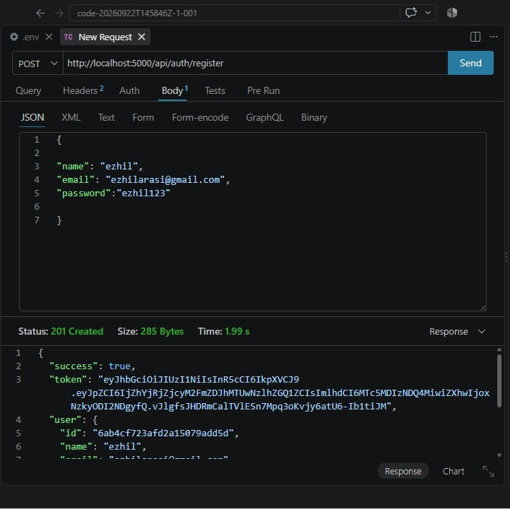
PROJECT EXECUTION:
The FitTrack AI backend can be executed as a Node.js application and tested through Postman or another REST API client.
User Registration

A new user can register by providing name, email, and password. The backend validates the request, hashes the password, stores the user in MongoDB, and returns a registration response.
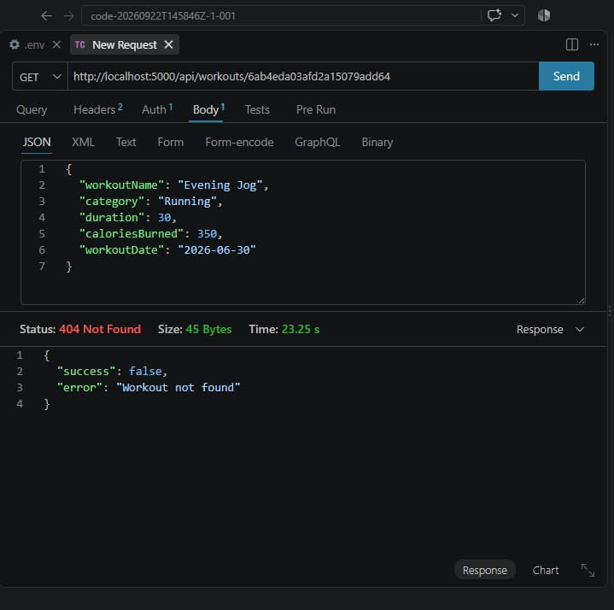
User Login
A registered user can log in using email and password. After successful password verification, the backend generates a JWT token for protected API access.
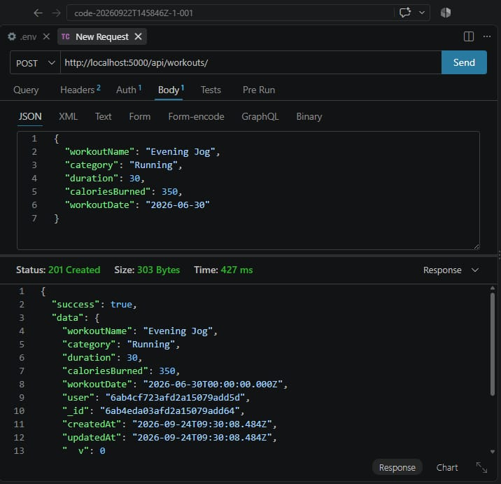
Workout Creation
An authenticated user can submit workout information including workout name, category, duration, calories burned, and workout date. The workout is associated with the authenticated user's ID.

PROJECT EXECUTION:
Workout Retrieval
The GET APIs retrieve stored workout records for the authenticated user. A specific workout can also be retrieved using its unique ID.
Workout Update
The PUT operation updates an existing workout record after authentication and validation.
Workout Deletion
The DELETE operation removes the selected workout record when the request is authenticated and the record is available.
Workout Search
The search functionality allows users to locate workout records using supported attributes such as workout name, category, or workout date.
AI Workout Recommendation
The recommendation API sends age, fitness goal, and experience level to the Gemini service and returns personalized workout guidance.
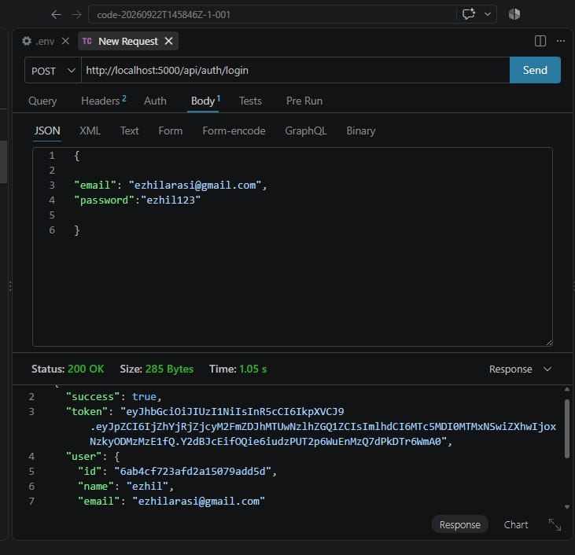

PROJECT EXECUTION:
Fitness Insights
The fitness insight API can analyze total workouts, average workout duration, and total calories burned and return AI-generated performance observations and improvement suggestions.
EXPECTED RESULT
The completed backend provides secure authentication, workout management, searchable workout history, AI-assisted recommendations, and fitness insights through RESTful JSON APIs.
PROJECT BASIS
This document follows the page sequence, headings, concise numbered implementation style, technology table, architecture flow, feature list, roles, user flow, and execution/output format of the uploaded NM document, while replacing the NM project's FAQ content with the FitTrack AI project's actual backend content.
GIT HUB LINK: https://github.com/ezhilarasipunithan/AI-FIT-TRACK-API.git
DEMO LINK: https://drive.google.com/file/d/1bfkD_pXqb9A5jfNosU7L13YQTJKXezTI/view?usp=drivesdk

